Pickup and Delivery Route Generation Using Genetic Algorithm

Introduction

In today’s industries, large scale companies are now applying E-commerce as a tool for convenience for people, e-commerce is a transaction of buying or selling online, like Amazon, Zalora, Lazada, Alibaba etc. but with the further use of e-commerce, logistic businesses are having trouble with the demand.

In this study, the researchers hope to develop a mobile-based app to generate an optimize route for pickup and delivery with time window, therefore reducing the cost for this logistic business in each trip. a system that is fully automated and time-efficient. Using Genetic Algorithm, the researchers think that it is feasible to be implemented in this type of problem.

Background of the Study:

e-Commerce industry faces several logistics challenges and it is not just about the lack of standardization in postal addresses. One of the major challenge is the logistical complexity, which consumes huge amount of capital and time to solve it. Small deliveries to many places causes complex routing problems. Deliveries are time-bound and are restricted to time periods and certain routes. Due to the dispersed customer location, it is difficult for the delivery guys to find the customer location

Companies operating in logistics industry face unique challenges as delivery guys operate in vast territories. The challenges these companies face include: No real-time coordination, Ineffective technology application, Admin work, Locating customer addresses, Visibility of field workforce

Time equals money in any business and to be honest, managing the field workforce in this competitive environment can be complicated. It is difficult to keep track of each and every driver or delivery boy which in turn results in inefficiency and late deliveries.

The genetic algorithm

The genetic algorithm is a method for solving both constrained and unconstrained optimization problems that is based on natural selection, the process that drives biological evolution. The genetic algorithm repeatedly modifies a population of individual solutions. At each step, the genetic algorithm selects individuals at random from the current population to be parents and uses them to produce the children for the next generation. Over successive generations, the population "evolves" toward an optimal solution. You can apply the genetic algorithm to solve a variety of optimization problems that are not well suited for standard optimization algorithms, including problems in which the objective function is discontinuous, nondifferentiable, stochastic, or highly nonlinear. The genetic algorithm can address problems of mixed integer programming, where some components are restricted to be integer-valued.

The genetic algorithm uses three main types of rules at each step to create the next generation from the current population: Selection rules select the individuals, called parents, that contribute to the population at the next generation. Crossover rules combine two parents to form children for the next generation. Mutation rules apply random changes to individual parents to form children.

This study aims to generate an Optimized route for pickup and delivery using Genetic Algorithm

1. Is Genetic Algorithm is applicable in generating route path?

2. How can route optimization reduce cost in pickup and delivery?

3. What is the efficiency in using this solution as to other solutions?

The objectives of this study is to develop an application that will generate an Optimized route for pickup and delivery using Genetic Algorithm to achieve the following objectives

a. To study if Genetic Algorithm is applicable in generating optimized route for pickup and delivery

b. To reduce cost of delivery and pickup by implementing Genetic Algorithm in routing

c. To study the efficiency of using Genetic Algorithm in generating optimize route for pickup and delivery

Conceptual Framework

Conceptual Framework of the system

The figure below illustrates the conceptual framework of the system. The needed tools for the system are shown below. First, in the input phase, the user will input location and time. In the process phase includes the validation phase if the location is existing. The genetic algorithm processes the information. The output of the system will be the generated route and schedule

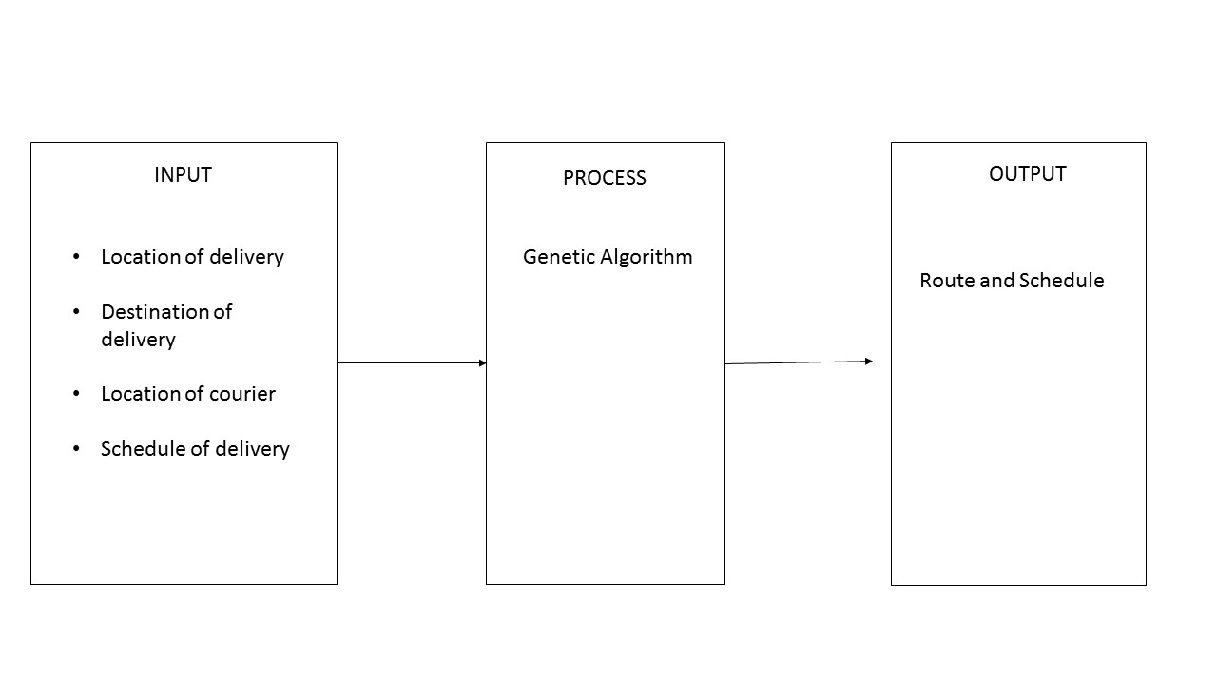

Figure 1.1 Conceptual Framework of the system

**CONCEPTUAL FRAMEWORK OF THE STUDY**

Figure 1.2 shows the conceptual framework of the study wherein the required input is the developed system for Pickup and Delivery Route Generation using Genetic Algorithm. Data gathering is through interview method and system testing. Data analysis and presentation is included in this phase. The output of the study will be the accuracy of the system in generating the route and schedule of pickup and delivery, conclusions and recommendations of the system.

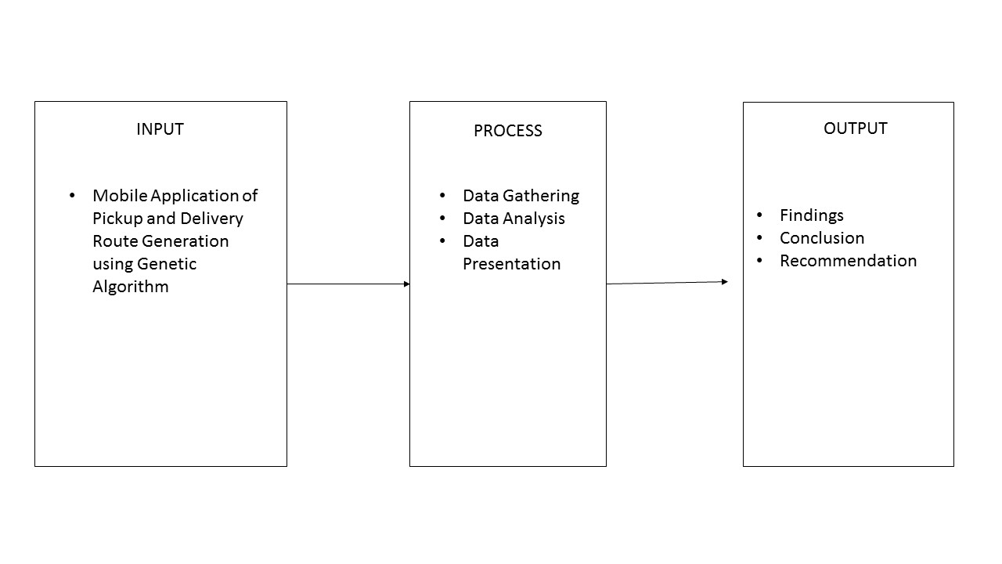

Figure 1.2 Conceptual Framework of the system

* 1. **SCOPE AND LIMITATIONS**

In general, the focus of this study is aimed to develop an application that will generate an optimized route for pickup and delivery. Metro Manila is selected to be the area to be studied and with 1-3 delivery couriers will be selected. The application can be used by the admin, user and the delivery couriers. The system has a secure login for the users and couriers. Managing pickup and delivery is integrated in the application. Although the research has reached its aims, there are still some unavoidable limitations. First, because of the limited time given, the research was conducted only on a small size of population. Therefore, to generalize the size for larger groups, the study should involve more participants at different age and locations. Finally, the slow network might affect the interest and motivation in participating in the study

Significance of the Study

Industrial Significance

The proposed system will introduce technology to businesses that are until now adapting manual delivery routing

Researchers

The researchers have developed their writing, analysis and interpretation skills that are needed to develop a viable thesis

Definition of Terms

Logistics - is generally the detailed organization and implementation of a complex operation. In a general business sense, logistics is the management of the flow of things between the point of origin and the point of consumption in order to meet requirements of customers or corporations.

Genetic Algorithm - is a method for solving both constrained and unconstrained optimization problems that is based on natural selection, the process that drives biological evolution.

The vehicle routing problem (VRP) - is a combinatorial optimization and integer programming problem which asks, "What is the optimal set of routes for a fleet of vehicles to traverse in order to deliver to a given set of customers?".

travelling salesman problem - a mathematical problem in which one tries to find the shortest route that passes through each of a set of points once and only once.